

Welcome to {CompanyNameHere} online onboarding and training platform! We are pleased that you are joining us, and we know that your contributions will assist us in remaining a leader in the legal industry. We have always ﬁrmly believed that outstanding people are the key to our success, and we are proud to have you as part of our team.

In this course, you’ll gain all the necessary tools to start your new job. This onboarding course will cover the following topics:

* First, you'll get a brief history of our company, what we stand for, and what you can expect from our community. You’ll also learn about our products and why customers love them.
* Then, you’ll explore the various teams at *{*CompanyNameHere*}* and how they fit together. This includes an introduction to your direct team members and team culture.
* The next section covers first-day business, like setting up your workstation and tools.
* In the “People” section, you’ll explore our benefits, including paid time off, health insurance, and retirement.
* Next, you’ll review the tools *{*CompanyNameHere*}*offers to grow your career, including reviews, education, and mentoring.
* Last but not least, you’ll find some required legal agreements. You’ll also get a handy checklist for your first day.

**A Message from our CEO**

{%CEOIMAGEHERE}

|  |
| --- |
| *Welcome to our company… {CompanyD}* |



**Lesson One**

**Our Mission and Values**

{CMissionHere}

{EQuote}

{Value 2}

{Value 3}

{Value 1}



**Lesson Two**

**Your First Week Checklist**

{#ItemFromChecklistHere}

* {item}

{/ItemFromChecklistHere}

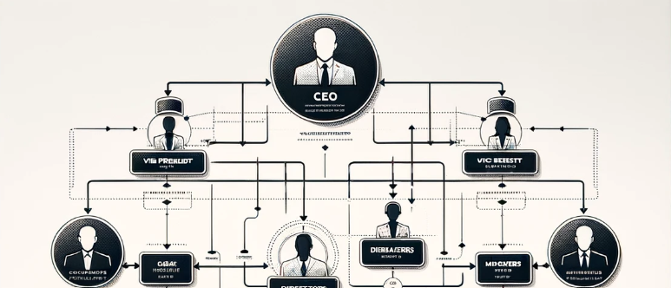

**Lesson Three**

**Company Structure and Contacts**

**I’ll do this later**